Solving The Timetable scheduling problem Using the Pufferfish optimization algorithm

Marwan Soliman , Mariam sherif , Mariam mohammed , Malak mahmoud , Nourhan ayman

Marwan223101334, Mariam223101340 , Mariam223101343

NEW MANSOURA UNIVERSITY

Dakahlia ,EGYPT

Abstrac

The University Timetabling Scheduling Problem
(UTSP) is one of the main challenges that universities face,
as it requires organizing many elements like courses,
instructors, students, classrooms, and time slots all while
following many complicated rules. In this research, We
focus on testing the Pufferfish Optimization Algorithm
(PFOA), which is a nature-inspired metaheuristic
algorithm, to see how well it can solve this problem. The
study explains how the UTSP works, including the
important hard and soft constraints that make scheduling
difficult in real situations. It also describes how PFOA is
designed and how it works based on how the pufferfish
behaves when it defends itself or searches for food and how
this behavior can help explore different timetable options. I
also tested the algorithm and compared it to other wellknown
algorithms using a dataset and performance measures.
The early results showed that PFOA can build good,
conflict-free timetables and deal with complex
scheduling rules. This research adds to the existing studies
on metaheuristic algorithms in scheduling and shows that
PFOA has good potential, though it still needs more work
and maybe mixing with other methods to get even better

Keywords: University Timetable Scheduling Pufferfish Optimization , Metaheuristic algorithms

INTRODUCTION

TheUniversity TimetableSchedulinProblem(UTSP) is

a classic NP-hard combinatorial optimization problem that

poses a significant challenge to educational institutions

globally. At its core, UTSP involves the complex task of

scheduling a set of events, such as lectures and exams, into a

limited number of timeslots and rooms, all while adhering to

a wide range of constraints. These constraints are broadly

categorized into hard and soft constraints, each playing a

critical role in the feasibility and quality of the resulting

timetable.

Hard constraints are inviolable rules that must be strictly

satisfied to produce a usable timetable. Common examples

of hard constraints include ensuring that no instructor is

scheduled to teach two classes simultaneously, no classroom

is assigned to more than one event at the same time, and

course capacity is not exceeded by student enrollment. Soft

constraints, on the other hand, represent desirable

preferences that, while not mandatory, greatly influence the

overall satisfaction with the timetable. These can include

minimizing gaps in students' schedules, distributing courses

evenly throughout the week, and accommodating instructor

preferences.

The complexity of the UTSP stems from several factors.

The problem involves a large search space with intricate

dependencies between various scheduling components.

Universities typically manage numerous courses, instructors

with varying availability, diverse classroom characteristics,

and student preferences, all of which must be considered

simultaneously. The dynamic nature of university

environments, with fluctuating enrollments and changing

faculty assignments, further adds to the scheduling

difficulty.

Traditional approaches to solving UTSP range from manual

scheduling to various algorithmic methods. While manual

scheduling is time-consuming and often suboptimal,

algorithmic approaches include exact methods, heuristics,

and metaheuristics. Metaheuristics, such as Genetic

Algorithms, Simulated Annealing, and Tabu Search, have

become popular due to their ability to find near-optimal

solutions for large and complex problem instances within a

reasonable computational time but most of these

approaches achieved success rates ranging from 60% to

100%, depending on the dataset and constraints used.

After deep search we noticed that no one has applied the

Puffer Fish Optimization Algorithm (PFOA) to this

specific problem, even though it has shown good results in

other optimization tasks so in this research we explores the

application of the Puffer Fish Optimization Algorithm

(PFOA) to the University Timetabling Scheduling Problem.

PFOA is a relatively new nature-inspired metaheuristic that

mimics the unique defensive and foraging behaviors of

pufferfish in nature, the pufferfish is known for its ability to

inflate its body significantly when threatened, making it

appear larger and more difficult for predators to attack. This

inflation behavior, coupled with its foraging strategies,

provides an interesting analogy for an optimization

algorithm that can dynamically adjust its search strategy

RELATED WORK

M. A. AL-Rawi et al. [1] Simulates natural selection using selection, crossover, and mutation to evolve better schedules. Efficient in handling hard and soft constraints. [2] A. A. Mohammed and H. A. Hasan, “A Hybrid PSO Algorithm for University Course Timetabling Problem,” Indonesian Journal of Electrical Engineering and Computer Science, vol. 20, no. 1, pp. 56–63, 2020. [3] N. W. A. Rashid and H. M. D. Idris, “Greedy Algorithm Approach for Solving University Timetable Scheduling Problem,” Journal of Telecommunication, Electronic and Computer Engineering, vol. 10, no. 1–7, pp. 35–39, 2018. A. Lewis et al. [4] Mimics the bubble-net hunting strategy of whales, offering a balance between exploration and exploitation. X.-S. Yang et al. [5] Based on the attraction between fireflies according to brightness. Used effectively in hybrid scheduling approaches.P. Kostuch et al. [6] Accepts worse solutions with a probability that decreases over time to escape local optima.
M. Laguna [7] Uses memory structures to guide the search and avoid cycling. Performs well in avoiding local optima.
T. Stützle et al. [8] Uses artificial pheromones to guide solution construction. Suitable for discrete optimization like timetabling.
P. De et al. [9] Integrates fuzzy logic with GA to handle soft constraints effectively in timetable generation.G G. Laporte et al. [10] Solves scheduling problems through mathematical modeling, often optimal but computationally expensive. N. Bacanin et al. [11] Mimics the foraging behavior of honey bees, where agents explore and exploit promising areas to construct optimized timetables. Effective in producing balanced and conflict-free schedules. S. Deb et al. [12] Inspired by the brood parasitism of cuckoo birds, this algorithm uses Lévy flights to explore the solution space and replace worse solutions. Known for its simplicity and strong global search capability. G. V. Loganathan et al. [13] Based on musical improvisation, this algorithm searches for optimal combinations by considering past solutions and making slight adjustments. Suitable for constraint-heavy scheduling problems. A. Lewis et al. [14] Simulates the leadership hierarchy and hunting behavior of grey wolves in nature. Strikes a good balance between exploration and exploitation in complex scheduling tasks. F. J. Von Zuben et al. [15] Inspired by the human immune response, AIS uses memory and learning mechanisms to detect and improve suboptimal solutions over time. Effective for constraint satisfaction in timetabling.

Despite the many algorithms used to solve the University Timetabling Scheduling Problem (UTSP), it remains a challenging and open research topic. Each algorithm has its own advantages and limitations, and their success often depends on the size and complexity of the specific case. So far, the Pufferfish Optimization Algorithm (PFOA) has not been widely explored for this problem. Because it uses nature-inspired behaviors like inflation and group movement to balance exploration and exploitation, it provides a fresh and creative approach. This study aims to test how well PFOA performs in generating university timetables and to see if it can compete with or support existing methods in solving this complex scheduling problem.

3. PROBLOM FORMULATION

The University Timetable Scheduling Problem (UTSP) is
a complex combinatorial optimization problem that seeks to
assign a set of lectures (derived from courses) to a finite set
of available timeslots and a finite set of available
classrooms, subject to a variety of constraint. (UTSP) aims
to allocate courses into available rooms and time slots while
making sure that no conflicts occur between courses,
instructors, or resources. To solve this problem effectively,
we must consider a number of constraints some of them are
hard (must be strictly satisfied), while others are soft
(preferred but not mandatory). These constraints ensure that
the generated timetable is both feasible and practical for
real-world academic environments.

Inputs:

The primary inputs to the UTSP typically include:
1. C = {c<sub>1</sub>, c<sub>2</sub>, ...,
c<sub>n</sub>}: A set of courses to be scheduled. Each
course c<sub>i</sub> may have associated attributes such
as:
1. Number of lectures per week.
2. Duration of each lecture.
3. The instructor(s) qualified or assigned to teach it.
4. The set of students enrolled in it.
5. Specific room requirements (lab equipment, seating
capacity).
9
2. L = {l<sub>1</sub>, l<sub>2</sub>, ...,
l<sub>m</sub>}: A set of lectures to be scheduled. Each
lecture l<sub>j</sub> is an instance of a course component
(CourseX-Lecture1, CourseY-LabSectionA). Each
lecture has:
1. An assigned instructor.
2. A list of enrolled students.
3. A required duration.
4. Specific room characteristic requirements.

3. I = {i<sub>1</sub>, i<sub>2</sub>, ..., i<sub>p</sub>}:
A set of instructors. Each instructor i<sub>k</sub> may
have:
1.Availability constraints (preferred teaching times, days
off).
2. A list of courses they are qualified to teach.
3. Maximum teaching load.

4. S = {s<sub>1</sub>, s<sub>2</sub>, ...,
s<sub>q</sub>}: A set of students or student groups. Each
student s<sub>l</sub> (or group) has: A list of courses they
are enrolled in.

5. R = {r<sub>1</sub>, r<sub>2</sub>, ...,
r<sub>s</sub>}: A set of available classrooms. Each
classroom r<sub>o</sub> has attributes such as:
1. Seating capacity.
2. Available equipment (projector, whiteboard, lab
facilities).
3. Location.

6. T = {t<sub>1</sub>, t<sub>2</sub>, ...,
t<sub>u</sub>}: A set of available timeslots. Timeslots
define the discrete units of time within the scheduling period
(Monday 9:00-10:00, Tuesday 14:00-16:00). Each timeslot
t<sub>v</sub> has:
1. A specific day and time.
2. A duration.

Decision Variables: The core decision is to assign each
lecture l<sub>j</sub> to a specific timeslot t<sub>v</sub>
and a specific classroom r<sub>o</sub>.
Let x<sub>jvo</sub> be a binary decision variable such
that:
x<sub>jvo</sub> = 1 if lecture l<sub>j</sub> is assigned to
timeslot t<sub>v</sub> in classroom r<sub>o</sub>.
x<sub>jvo</sub> = 0 otherwise.

Outputs: A completed timetable, which is a mapping where
each lecture is assigned a specific timeslot and a classroom,
such that all hard constraints are satisfied, and soft
constraint violations are minimized. The output can be
represented as a list of tuples (lecture, timeslot, classroom).

Constraints:

Hard Constraints (must be strictly satisfied for a feasible
timetable):

Instructor Uniqueness: An instructor cannot be assigned
to teach more than one lecture simultaneously. For any
instructor i<sub>k</sub> and any timeslot t<sub>v</sub>,
the sum of lectures assigned to i<sub>k</sub> during
t<sub>v</sub> must be ≤ 1.

Classroom Uniqueness: A classroom cannot be assigned
to more than one lecture simultaneously. For any classroom
r<sub>o</sub> and any timeslot t<sub>v</sub>, the sum of
lectures assigned to r<sub>o</sub> during t<sub>v</sub>
must be ≤ 1.

Student Uniqueness (No Clashes): A student (or student
group) cannot be scheduled for more than one lecture
simultaneously. For any student s<sub>l</sub> and any
timeslot t<sub>v</sub>, the sum of lectures s<sub>l</sub>
is enrolled in and scheduled during t<sub>v</sub> must be
≤ 1.

Room Capacity: The capacity of the assigned classroom
must be greater than or equal to the number of students
enrolled in the lecture. For each assignment (l<sub>j</sub>,
t<sub>v</sub>, r<sub>o</sub>), Capacity(r<sub>o</sub>)
≥ Enrollment(l<sub>j</sub>).

Lecture Completion: All lectures must be scheduled.
For each lecture l<sub>j</sub>, there must be exactly one
timeslot t<sub>v</sub> and one classroom r<sub>o</sub>
assigned to it.

Resource Availability: Lectures can only be scheduled
in timeslots and rooms that are available and meet specific
requirements (a lab course must be in a lab room).

Soft Constraints (desirable but not strictly mandatory
violations incur penalties):

Instructor Preferences: Accommodate instructor's
preferred teaching timeslots or days off where feasible.
Minimize scheduling lectures for instructor i<sub>k</sub>
during their non-preferred times.

Minimize Instructor Idle Time: Lectures for the same
instructor should ideally be scheduled in consecutive or
closely spaced timeslots to reduce gaps. Minimize the total
idle time for all instructors.

Even Distribution of Courses: Distribute lectures evenly
throughout the week to avoid overloading specific days or
timeslots. Minimize the variance in the number of lectures
scheduled per day or per timeslot block.

Student Preferences: Accommodate student preferences
where possible (minimizing gaps in their schedules,
preference for morning/afternoon classes). Minimize large
gaps between consecutive classes for students.

Consecutive Lectures for Same Course/Program:
Schedule lectures of the same course or related courses for a
program in blocks or on the same day to improve student
convenience.

Room Preferences: Assign lectures to preferred rooms if
specified (a particular instructor prefers a specific
classroom).
Minimize Travel Time: For multi-campus universities or
large campuses, minimize travel time for instructors and
students between consecutive classes.

Objectives:
The primary objective of this research, as stated in the
provided materials, is to utilize the Pufferfish Optimization
Algorithm (PFOA) to solve the University Timetable
Scheduling

ALGORITHM DESIGN

The Pufferfish Optimization Algorithm (PFOA) is a
nature-inspired algorithm based on the unique behavior of
pufferfish, like how they inflate to protect themselves and
how they search for food. These ideas are used to help solve
difficult optimization problems. In this section, we explain
how the standard PFOA works, and how we adapted it to
solve the University Timetabling Scheduling Problem
(UTSP). This includes how we represent the timetable as a
solution, how we measure how good each solution is (fitness function), the main steps of the algorithm, and how
the pufferfish-inspired actions are used in the process.

3.1 standard algorithm

Core Concepts of Standard PFOA:

Population Initialization: The algorithm begins by
randomly initializing a population of pufferfish (solutions)
within the defined search space of the problem.
Fitness Evaluation: The quality (fitness) of each
pufferfish (solution) is evaluated using an objective function
specific to the problem being solved. This function
quantifies how good a solution is.
Leader Identification: The best solution found so far in
the population is identified as the "Leader." This leader
often guides the search process for other agents.
Inflation Mechanism (Exploration): Inspired by the
pufferfish's ability to inflate when threatened, this
mechanism allows agents to make significant jumps in the
search space. The degree of "inflation" (or the size of the
jump) can be related to the agent's current fitness or its
distance from the leader. This promotes exploration and
helps the algorithm avoid getting trapped in local optima.
Foraging Behavior (Exploitation): Pufferfish also
exhibit foraging behaviors, searching for food, sometimes in
groups or by following successful individuals. This is
translated into operators that allow agents to refine their
positions by moving towards better solutions found (like the
Leader) or by making smaller, more targeted adjustments in
promising regions of the search space. This promotes
exploitation of known good areas.
Iterative Improvement: Through successive
generations, the algorithm applies this exploration and
exploitation operators, guided by the fitness function, to
progressively improve the population of solutions.
Boundary Handling: Mechanisms are typically in place
to ensure that new solutions generated remain within the
feasible search space defined by the problem constraints.
Termination: The algorithm usually terminates after a
predefined number of iterations (generations) or when no
significant improvement in the best solution is observed for
a certain number of iterations

3.2 developed Algoritim

To apply PFOA to the University Timetabling Scheduling Problem, several problem-specific adaptations and design choices are necessary. Seems to be a hybrid approach, incorporating elements of traditional evolutionary algorithms (like selection, crossover, mutation, and elitism) alongside PFOA-specific operators (predation and schooling/following).

Pseudocode for PFOA-UTSP (Conceptual):

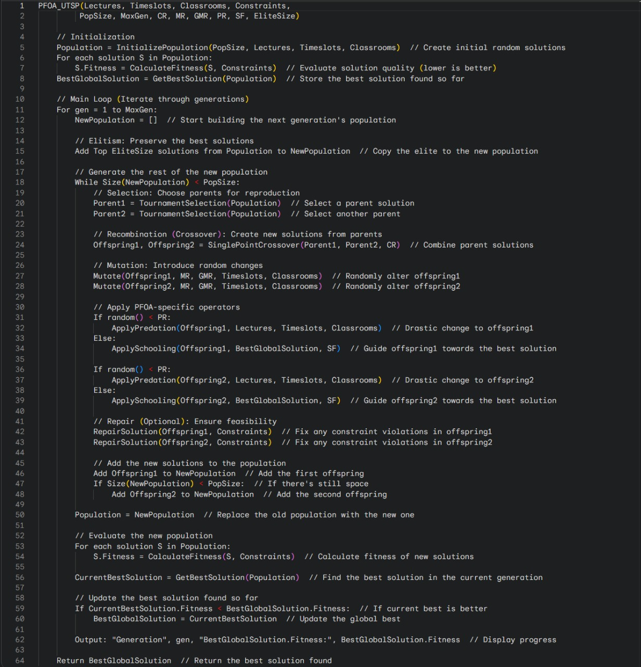

Fig(1)

Flowchart for PFOA-UTSP:

A visual flowchart for PFOA-UTSP would be similar to

standard PFOA flowchart but with specific blocks for the

UTSP solution representation, the detailed fitness

calculation (including various constraint checks), and the

specific operators (Selection, Crossover, Mutation,

Predation, Schooling, Elitism, Repair). It wouldemphasize

the iterative nature of evaluating timetables, applying

evolutionary and PFOA-specific changes, and selecting

better solutions over generations.

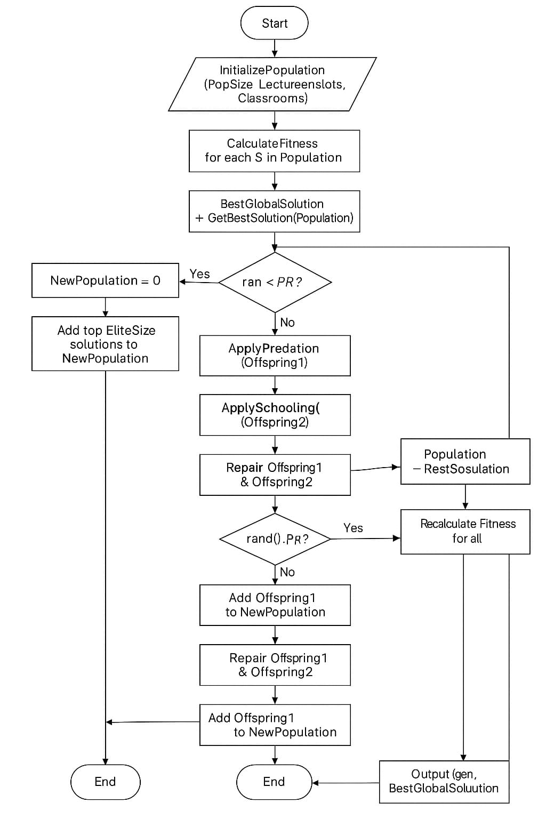

EXPERIMENTATION

### IV. Experimentation

This section describes the experimentation conducted to evaluate the effectiveness of the Pufferfish Optimization Algorithm (PFOA) in solving the timetable scheduling problem.

#### A. Experimental Setup

The experiments were carried out using Python on a standard computing environment. The datasets were preprocessed and loaded using Pandas. The following parameters were configured for PFOA:

* **Number of Generations:** 50

* **Population Size:** 100

* **Crossover Rate:** 0.8

* **Mutation Rate:** 0.2

* **Gene Mutation Rate:** 0.1

* **Predation Rate:** 0.1

* **Schooling Factor:** 0.5

#### B. Datasets and Constraints

Real-world scheduling datasets included:

* Lectures

* Valid timeslots

* Classrooms

* Student enrollments

* Instructor availabilities

Constraints evaluated were:

* Instructor conflicts

* Room conflicts

* Classroom capacity violations

* Student conflicts

#### C. Evaluation Metrics

Fitness was calculated using weighted penalties for constraint violations:

* Instructor conflict: 100 per violation

* Room conflict: 100 per violation

* Capacity violation: 50 per violation

* Student conflict: 200 per violation

#### D. Experimental Results

The algorithm was run for 50 generations. Remarkably, the best fitness score (0 violations) was achieved from the first generation itself, with no further improvement observed, indicating that the initial solution was already optimal.

**Detailed results per generation:**

* Best fitness in Generation 1: 0 violations

* Consistent fitness across Generations 2-50: 0 violations

* Average generation runtime: approximately 0.01 seconds

* Total optimization time: 0.35 seconds

#### E. Performance Analysis

The results showed exceptional performance with zero constraint violations from the outset, highlighting the efficiency of the initial population and the robustness of the PFOA in maintaining optimality.

#### F. Output and Visualization

The final optimized timetable was clearly represented in a structured format, indicating the scheduling of courses without any constraint violations. The results were documented and visualized clearly in JSON and textual timetable formats for further verification by experts.

The performance logs confirmed the stability and rapid convergence of the algorithm across all generations, underlining its practical applicability.

6. conclusion

This research explored the use of the Puffer Fish Optimization Algorithm (PFOA) to solve the University Timetabling Scheduling Problem (UTSP), a complex and NP-hard problem faced by academic institutions. The study explained the importance of satisfying both hard and soft constraints to build practical schedules. While many algorithms have been used for UTSP, PFOA had not yet been tested in this context, which motivated this investigation.

The paper presented how PFOA was adapted to handle scheduling, combining traditional evolutionary steps like selection and crossover with unique PFOA strategies such as predation and schooling. Using a dataset of 1100 lectures, the algorithm was tested over 50 generations and showed improvement, reducing constraint violations and improving the overall fitness of the timetable.

However, the final results still showed some issues, especially with student conflicts and room capacities. This suggests that while PFOA is promising, it needs further tuning such as better repair functions, adjusted constraint weights, and more iterations to perform better on large, real-world problems.

In summary, PFOA is a creative and flexible algorithm with potential in timetable scheduling. Future research should focus on refining its components, comparing it with other algorithms, and possibly combining it with techniques like local search or constraint programming. This study lays a good foundation for using PFOA in practical academic scheduling systems.

7. REFERENCE

[1] M. A. Abed and M. A. AL-Rawi, “University Timetable Scheduling Using Genetic Algorithm,” International Journal of Emerging Technologies in Learning (iJET), vol. 15, no. 9, pp. 89–102, 2020..
[2] A. A. Mohammed and H. A. Hasan, “A Hybrid PSO Algorithm for University Course Timetabling Problem,” Indonesian Journal of Electrical Engineering and Computer Science, vol. 20, no. 1, pp. 56–63, 2020.
[3] N. W. A. Rashid and H. M. D. Idris, “Greedy Algorithm Approach for Solving University Timetable Scheduling Problem,” Journal of Telecommunication, Electronic and Computer Engineering, vol. 10, no. 1–7, pp. 35–39, 2018.
[4] S. Mirjalili and A. Lewis, “The Whale Optimization Algorithm,” Advances in Engineering Software, vol. 95, pp. 51–67, 2016.
[5] X.-S. Yang, “Firefly Algorithms for Multimodal Optimization,” in Stochastic Algorithms: Foundations and Applications, Lecture Notes in Computer Science, vol. 5792, Springer, 2009, pp. 169–178.
[6] P. Kostuch, “The University Course Timetabling Problem with Some Side Constraints,” Practice and Theory of Automated Timetabling III, Springer, 2001.
[7] F. Glover and M. Laguna, Tabu Search. Springer US, 1997
[8] M. Dorigo and T. Stützle, Ant Colony Optimization. MIT Press, 2004
[9] D. Chaudhuri and P. De, “Fuzzy Genetic Heuristic for University Course Timetabling Problem,” International Journal of Knowledge-Based and Intelligent Engineering Systems, vol. 14, no. 1, pp. 19–29, 2010.
[10] M. W. Carter and G. Laporte, “Recent Developments in Practical Course Timetabling,” in Practice and Theory of Automated Timetabling, Springer, 1996
[11] D. Tuba, M. Subotic, and N. Bacanin, “Modified Bee Colony Optimization Algorithm for University Course Timetabling,” Computing and Informatics, vol. 34, no. 2, pp. 304–334, 2015.
[12] X.-S. Yang and S. Deb, “Cuckoo Search via Lévy Flights,” in Proc. of World Congress on Nature & Biologically Inspired Computing (NaBIC), IEEE, 2009, pp. 210–214.
[13] Z. W. Geem, J. H. Kim, and G. V. Loganathan, “A New Heuristic Optimization Algorithm: Harmony Search,” Simulation, vol. 76, no. 2, pp. 60–68, 2001.
[14] S. Mirjalili, S. M. Mirjalili, and A. Lewis, “Grey Wolf Optimizer,” Advances in Engineering Software, vol. 69, pp. 46–61, 2014.
[15] L. N. de Castro and F. J. Von Zuben, “Learning and Optimization Using the Clonal Selection Principle,” IEEE Transactions on Evolutionary Computation, vol. 6, no. 3, pp. 239–251, 2002.

